Scenario 4: Copy EBS snapshot across regions (cross-region snapshot copy).
We have snapshot in ap-south-1(Mumbai), and we need this snapshot to be copied in us-east-1 (N. Virginia) so you need the same windows server with volume to be available in us-east-1 region.
Cross-region snapshot copying is commonly used for:
- Disaster Recovery
- Migration to another region
- Creating identical environments
- Regulatory requirements
Step1: select the snapshot you want to copy
Step 2: actions>click on copy snapshot
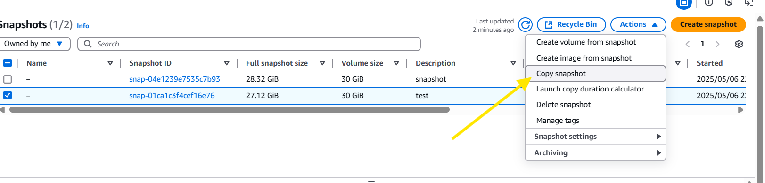
Step 3: specify the region and encryption. And click on copy snapshot.
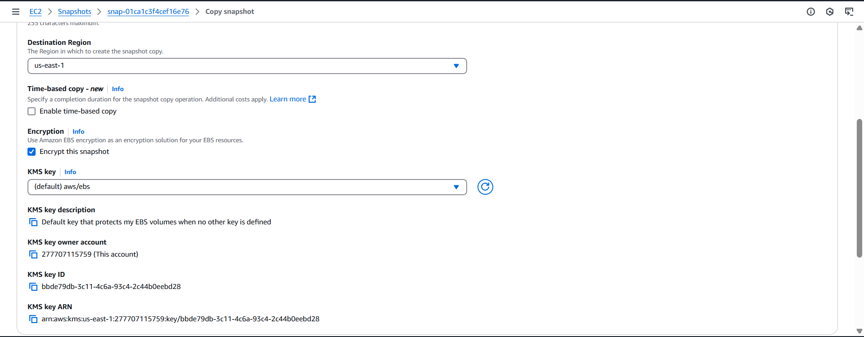
Step 4: lets validate
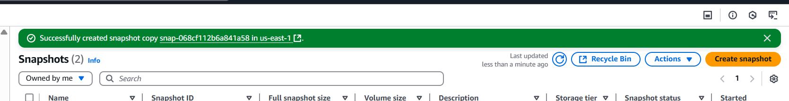
Step 5: switch region to us-east-1 , go to EC2 dashboard and scroll down to EBS snapshots and validate.
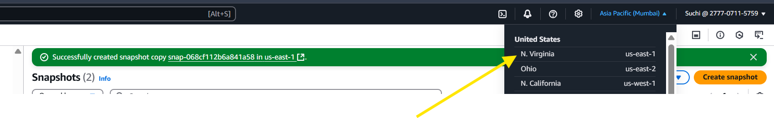
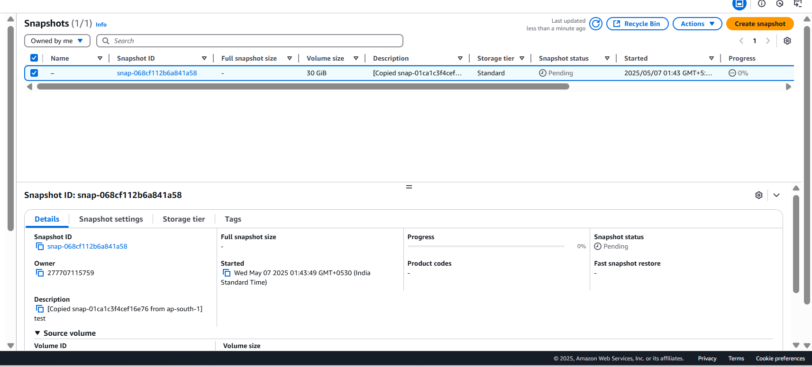
We could see that snapshot is been replicated , since it takes time its in progress.

